When the page is loaded for the first time, it will display the default values set in the state

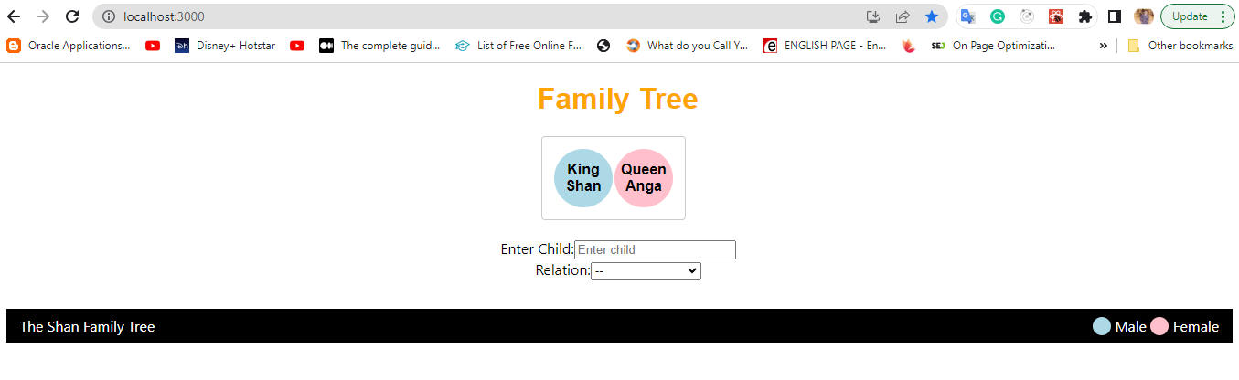

Steps to create the First generation:

Enter the child's name Ish in the respective text field and click on King Shan to get a Male Child / Queen Anga to get a female child.

Entered Ish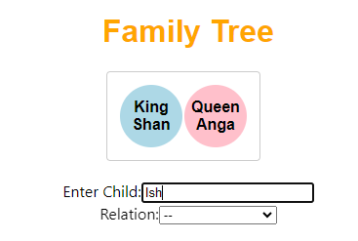

Click on King Shan to automatically get Ish child added to the first generation tree

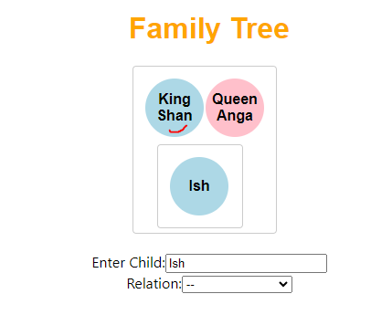

Now add second child Chit. Enter the Chit name in Enter Child text box as mentioned below.

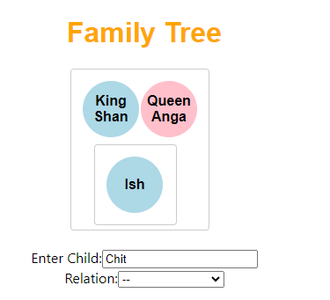

Click on King Shan to automatically create Chit child

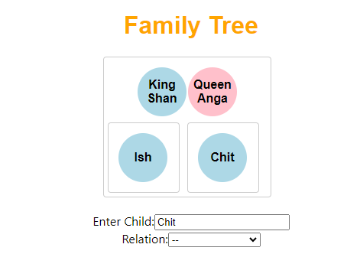

Now add spouse Ambi to Chit, then select spouse in the relation select dropdown, then click on Chit to automatically add a spouse to Chit as mentioned below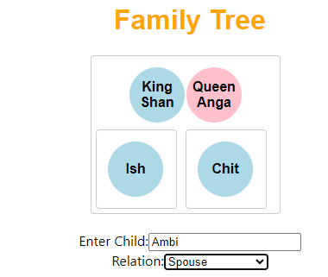

Click on Chit

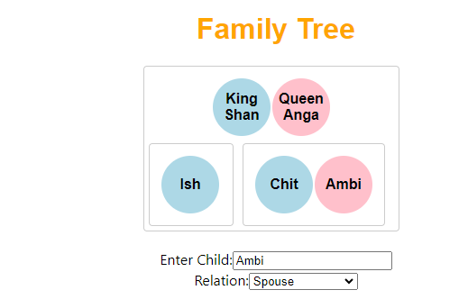

Similarly for Vish

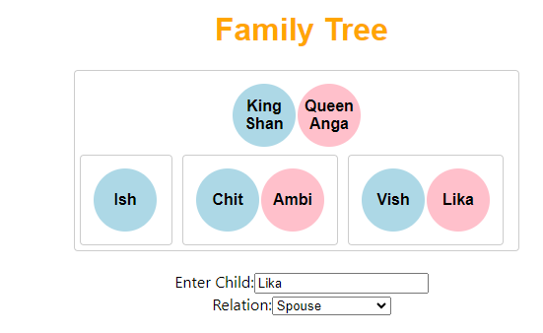

For Girl Child, add name in the Enter Child field and click on Queen Anga

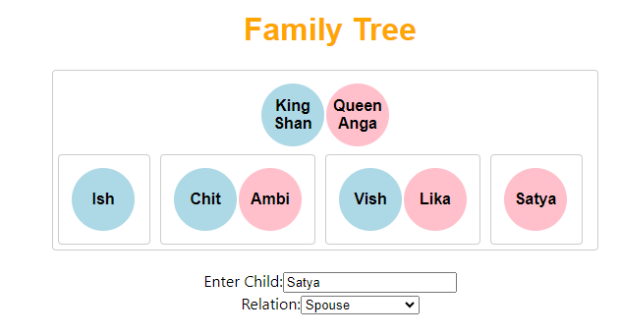

Adding Husband to Satya, enter husband name Vyan, choose Husband from Relation field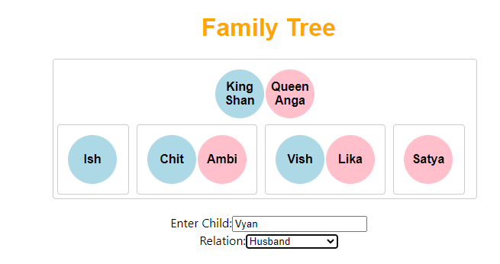

Click on Satya to automatically add husband to Satya

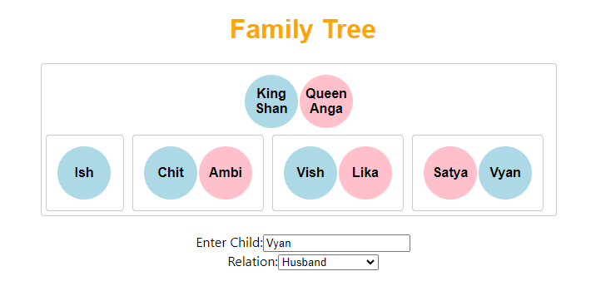

Add Second generation children similar to the first generation. But in relation, we have to select Child in the relation field as mentioned below.

Add Drita to Chit & Ambi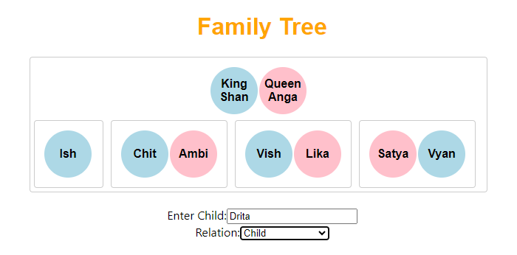

Since Drita is male Child, click on Chit

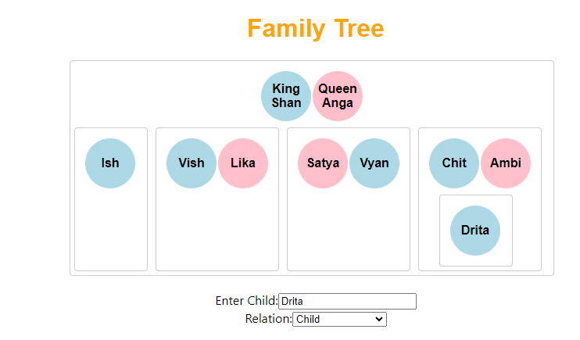

Add spouse Jaya to Drita, select spouse in relation, then click on Drita to add Jaya to Drita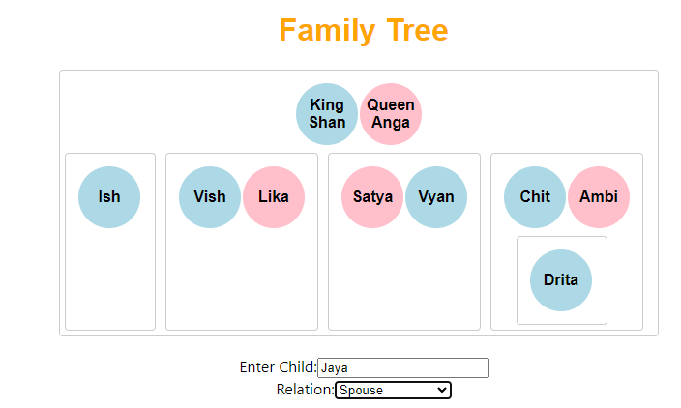

Click on Drita

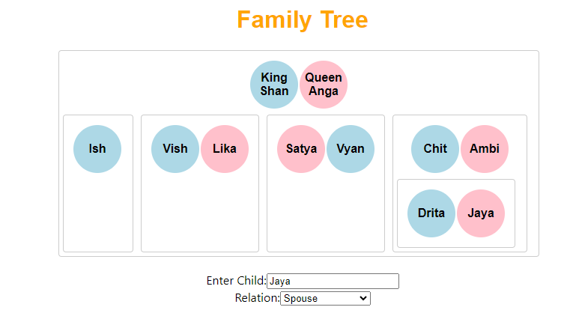

Add Vrita’s male child to Chit

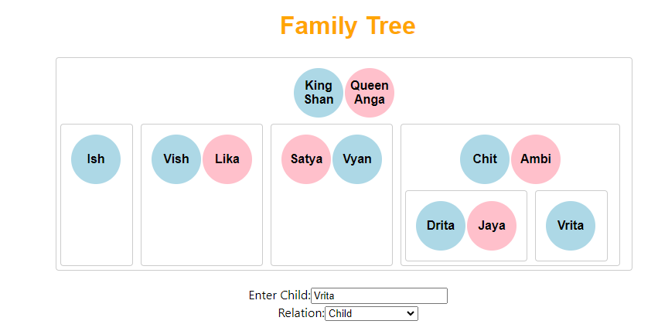

Add child Vila to Vish

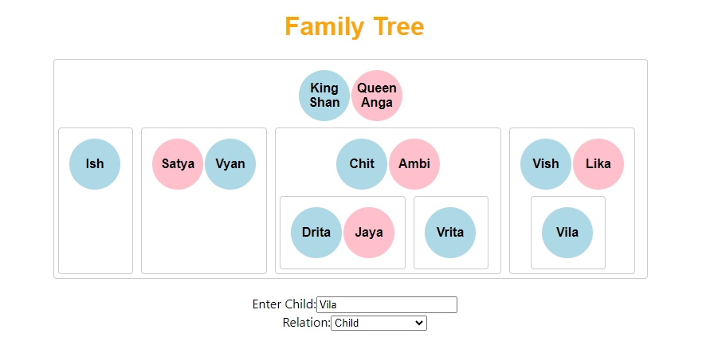

Add spouse Jnki to Vila, enter Jnki in enter child, then choose spouse in relation.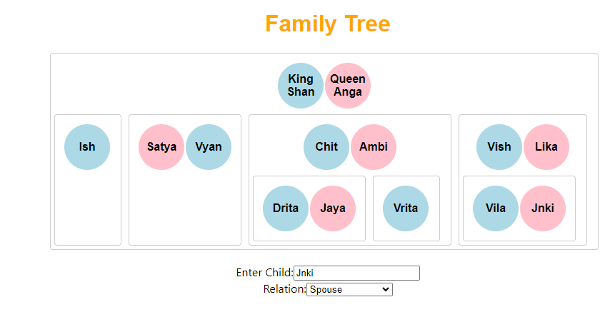

Add girl child Chika to Vish, enter Chika in enter child, select a child in Relation, click on Lika(to get girl child)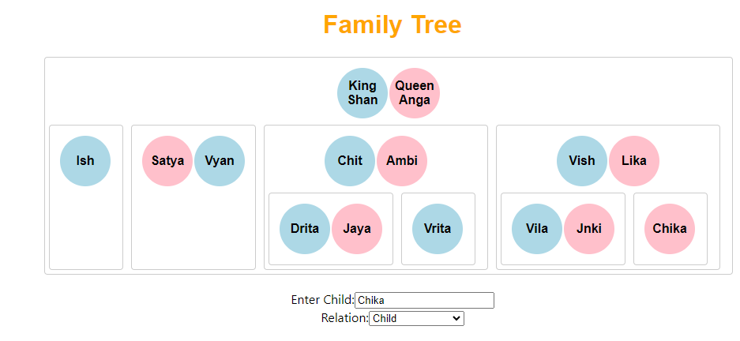

Enter husband to Chika, enter Kpila in Enter Child, and choose a husband in relation

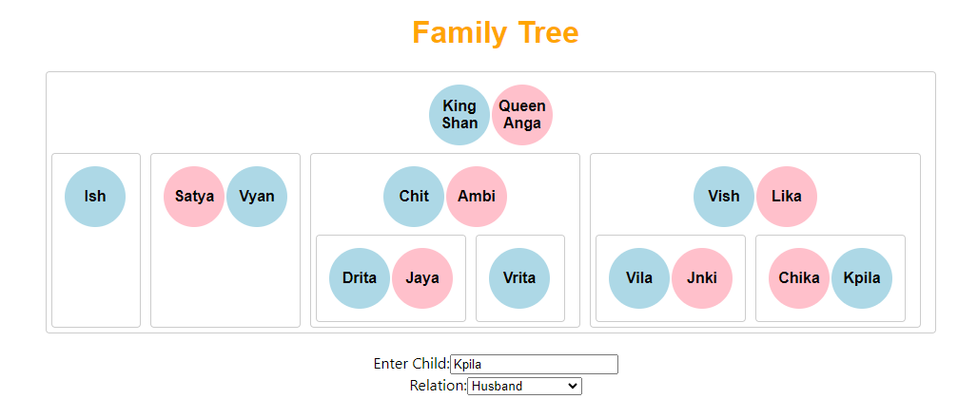

Similarly, add a child to Satya Vyan

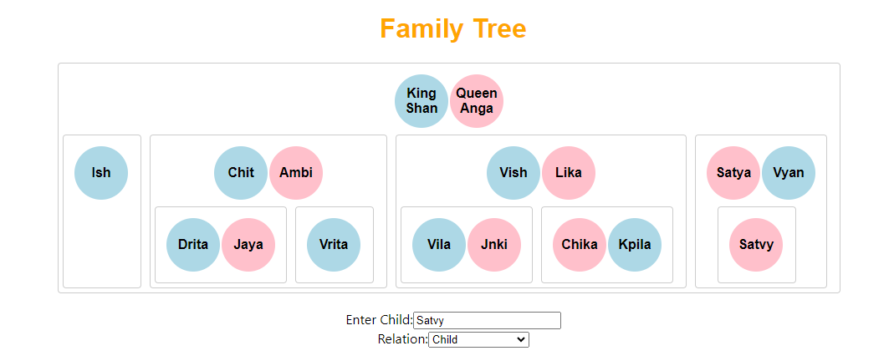

Add husband Asva to Satvy

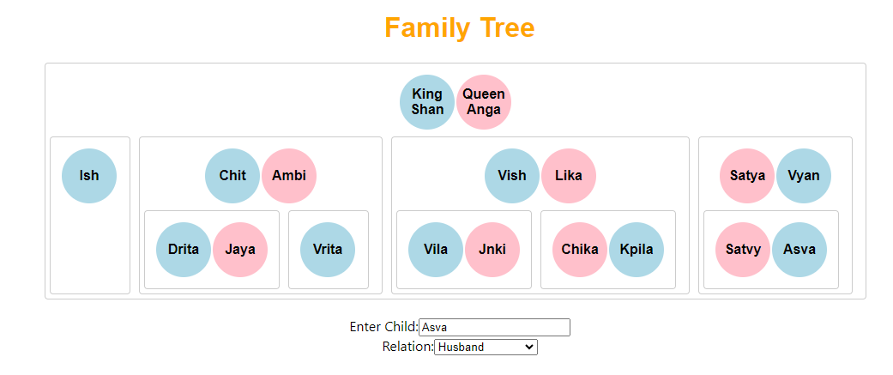

Add other children as mentioned in the document

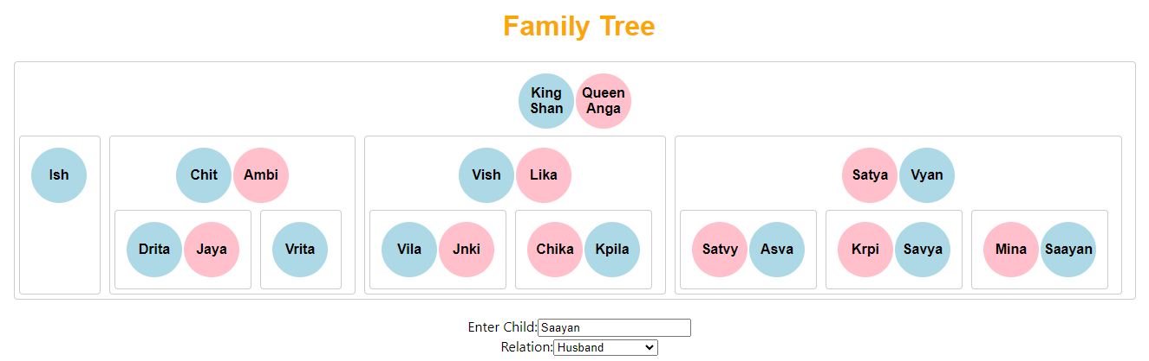

Now Add Grandchildren

Add Driya to Jaya, but here select Grand Child in relation and click on Jaya to get girl child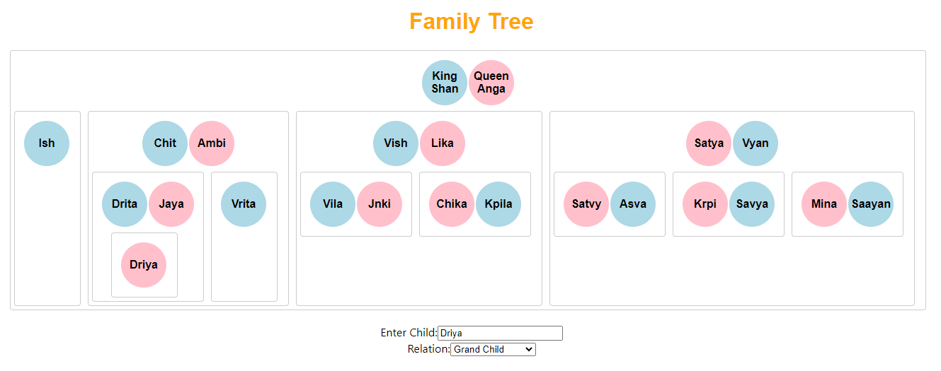

Lavanya to Jnki

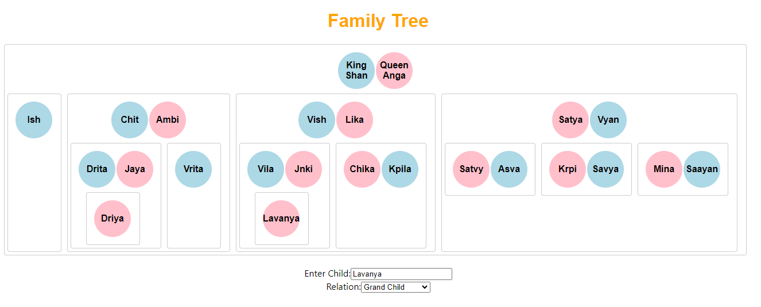

Problem 1: Meet the Family

1.Get brothers of Ish: Select Brothers in the Relation field and click on Ish to get Chit & Vish as brothers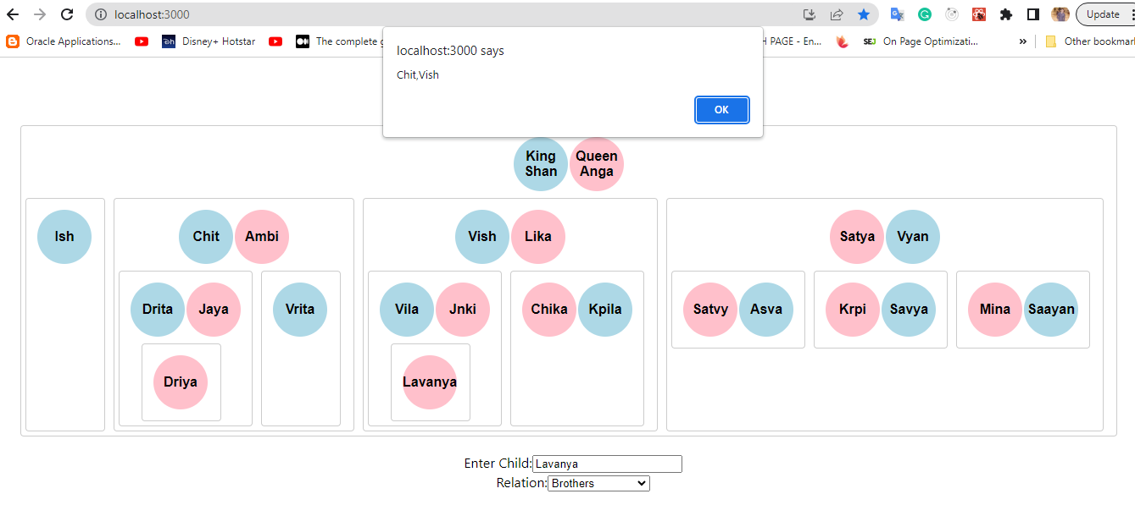

To get all brothers/sisters of the first generation, select Brothers / Sisters in Relation

Ex: Brothers

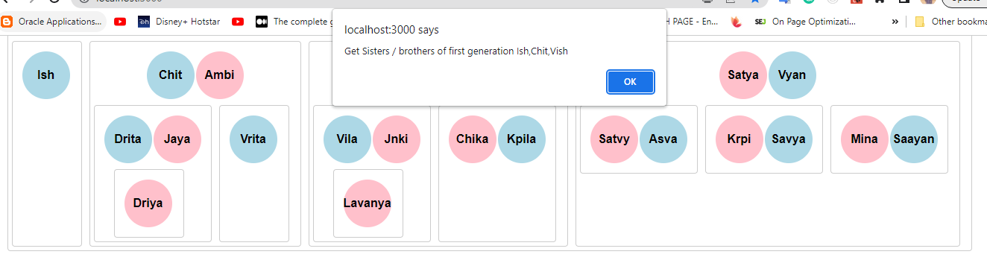

Ex: Sisters

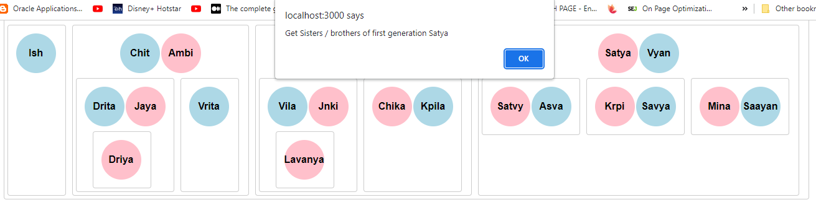

Problem 2: A new Born.

Solution: As depicted above, I have added male, and female children, grandchildren, etc to the family tree

Q 2.1: To get respective values based on name and relationship. This question seems to be confusing between expected output and question. Hence I am displaying a few examples based on relationships.

Get all Sisters in-laws of the first generation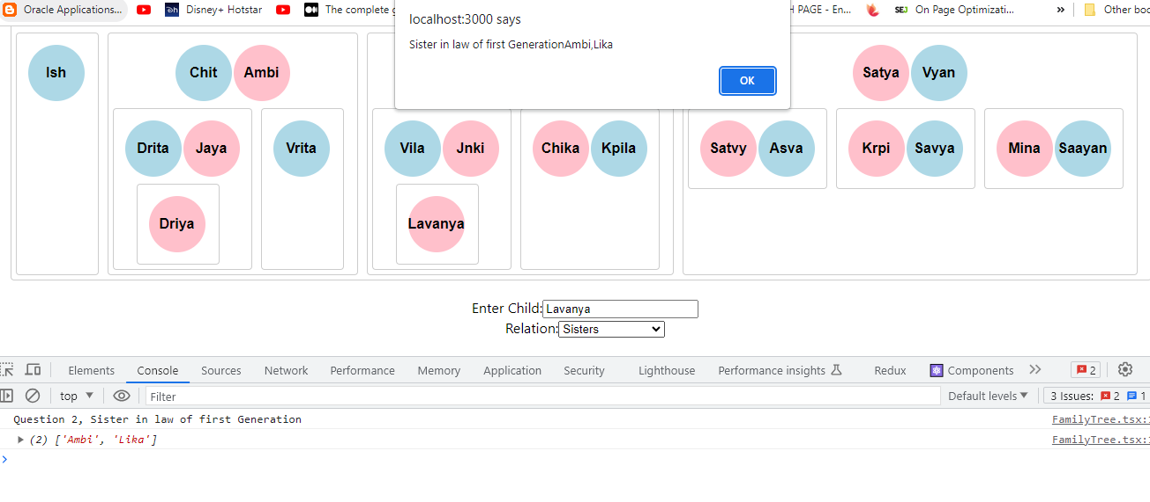

Get all grandchildren, alert triggers before switching the value while selecting in the Relation field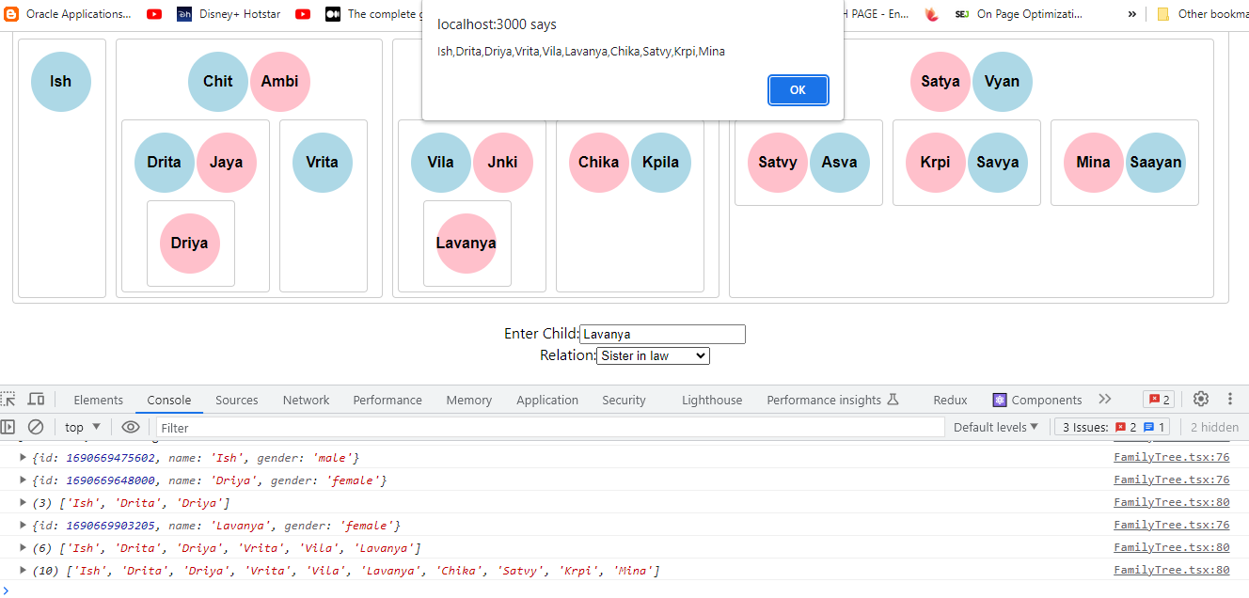

Problem 3: The Girl Child

Adding a girl / male child to the tree was shown in previous screenshots.

Showing all the mothers who have a girl child